1. Attract the right audience with localized SEO

Websites translated by Text United can be indexed by Google and other major search engines.

Every translated page of your website must have a single unique URL, which the search engines will index and display inside the search results. So if your website is translated into three different languages (and the fourth being the source language), you should have exactly three alternative unique URLs identifying every page inside the website, plus the fourth URL being the default one identifying the source language of the page.

Additionally, Text United supports translation of Meta Tags. Text United is extracting two types of meta tags for translation:

meta name="description"  
meta name="keywords"

The title tag from the head section of your website is extracted as translatable content as well. Other tags are not extracted since they usually contain content that is irrelevant from translation perspective.

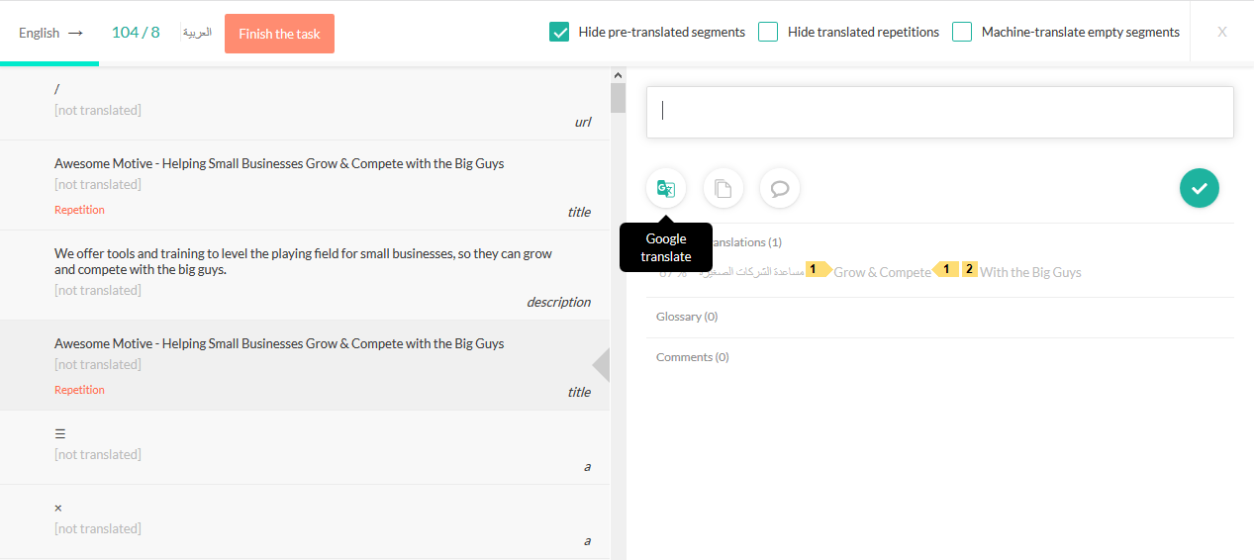

## Create market-specific content

Ecommerce stores may have to be adjusted to specific regions. Text United supports RTL text direction for Arabic and Hebrew by default, but you will still need to adjust the layout of you website. From aligning the text to the left to moving pictures and objects to the opposite side.

While any visual and content changes you make to your website, you will be always able to update the translated version as well. From Project Settings, websites can be rescanned and synced to pick up all your recent changes.

